Cc102
Module 1
Computer Programming 1

Contents:
- MODULE 1: CRITICAL THINKING SKILL used to analyze and evaluate complex problems
- MODULE 2: LOGICAL THINKING
- MODULE 3: ALGORITHMS, FLOWCHARTS, DATA TYPES, and PSEUDO CODE
CRITICAL THINKING

[1] The ability to think clearly and rationally, understanding the logical connection between ideas. Critical thinking has been the subject of much debate and thought since the time of early Greek philosophers such as Plato and Socrates and has continued to be a subject of discussion into the modern age, for example the ability to recognize fake news.

[2] Critical thinking might be described as the ability to engage in reflective and independent thinking.

[3] In essence, critical thinking requires you to use your ability to reason. It is about being an active learner rather than a passive recipient of information.

[1.1] Critical thinkers rigorously question ideas and assumptions rather than accepting them at face value. They will always seek to determine whether the ideas, arguments and findings represent the entire picture and are open to finding that they do not.

[1.2] Critical thinkers will identify, analyze and solve problems systematically rather than by intuition or instinct.

CRITICAL THINKING, DEFINED:

- “It is the mark of an educated mind to be able to entertain a thought without accepting it.”
― Aristotle, Metaphysics
- “All that we are is the result of what we have thought: it is founded on our thoughts and made up of our thoughts.”
― Buddha, Dhammapada
- “Learning without thought is labor lost; thought without learning is perilous.”
― Confucius, Analects
- “Read not to contradict and confute; nor to believe and take for granted; nor to find talk and discourse; but to weigh and consider.”
― Francis Bacon, “Of Studies”
- “The important thing is not to stop questioning. Curiosity has its own reason for existing.”
― Albert Einstein

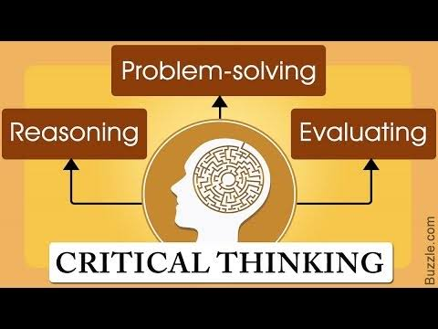
CRITICAL THINKING SKILL CHARACTERISTICS

Critical thinking is thinking about things in certain ways to arrive at the best possible solution in the circumstances that the thinker is aware of. In more everyday language, it is a way of thinking about whatever is presently occupying your mind so that you come to the best possible conclusion.

The Skills We Need for Critical Thinking
To think critically are varied and include:
- Observation
- Analysis
- Interpretation
- Reflection
- Evaluation
- Inference
- Explanation
- Problem solving
- Decision making

SOMEONE WITH CRITICAL THINKING SKILLS CAN:
- Understand the links between ideas.
- Determine the importance and relevance of arguments and ideas.
- Recognize, build and appraise arguments.
- Identify inconsistencies and errors in reasoning.
- Approach problems in a consistent and systematic way.
- Reflect on the justification of their own assumptions, beliefs and values.

CRITICAL THINKING INCOLVES:
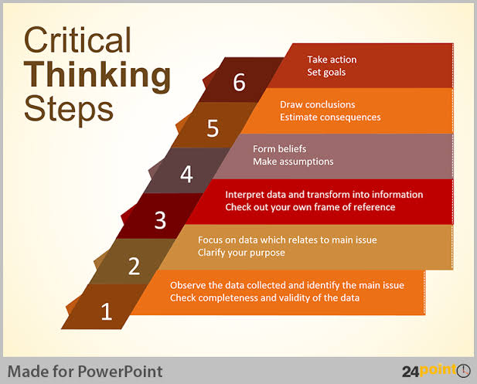
- Agreeing or disagreeing with a point of view
- Conceding that an argument may have this merit
- Comparing different viewpoints
- Proposing a different point of view
- Bringing together differing points of view by adding a new perspective.
- Applying your knowledge to different contexts
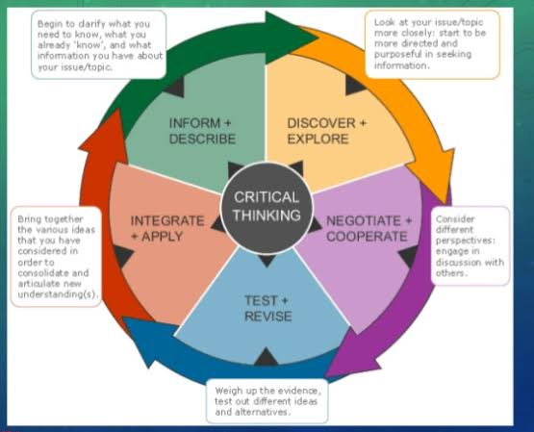
- Coming to a conclusion and being able to make inferences.

Importance of critical thinking

- Cornerstone of all academic activity
- Helps you to adapt a critical distance towards yours and other peoples work/ideas.
- Means of pushing the boundaries of knowledge forward by examining messy, grey areas
- Goes hand-in-hand with academic content.
- Essential for developing other academic skills.
- Promotes an (pro)active, independent and
- reflective approach to learning
- Soft employment skill - transferable to the workplace

CRITICAL THINKING AS A PROCESS

- Topic

Sub Topic

Bullet and Numerical

Extra Informations

